Press release

Palsgaard launches “next-level” PGPR for chocolate
JUELSMINDE, Denmark, 26TH May 2021

Palsgaard has launched a new PGPR product which offers chocolate manufacturers the best ever levels of functionality and efficiency.

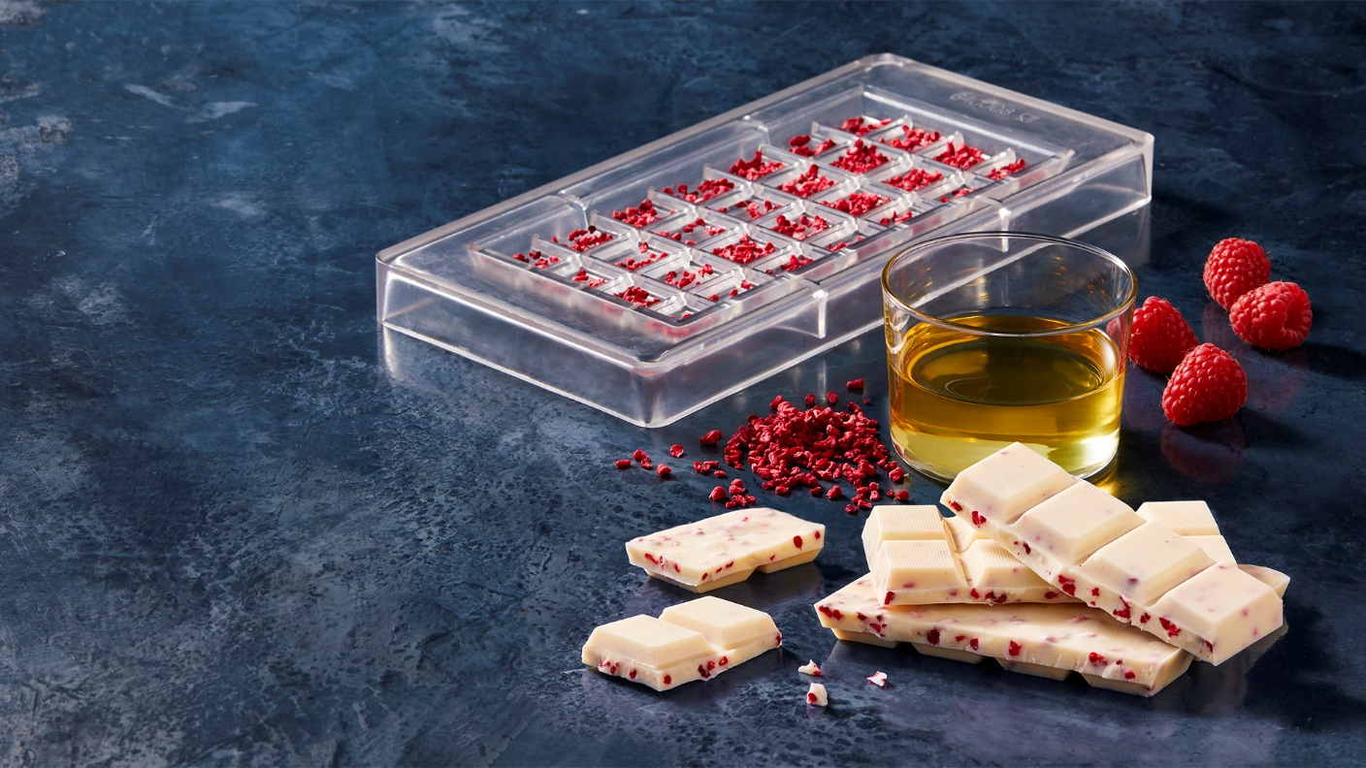

PGPR (polyglycerol polyricinoleate) is used in chocolate production for mould optimisation, flow control and viscosity reduction. Palsgaard’s existing product, Palsgaard® PGPR 4150, is already the market leader, but the company’s latest offering takes PGPR performance to new levels.

Developed exclusively for chocolate, Palsgaard® PGPR 4190 is 15% more efficient at controlling viscosity than Palsgaard® PGPR 4150, and can be used at a dose 30-40% lower than other PGPRs, making it highly cost-effective.

Other benefits include easier flow, better coating of inclusions, and taste- and odour-neutrality. Palsgaard® PGPR 4190 will be subject to Palsgaard’s unique quality standards, with batch-to-batch checks guaranteeing uniform stability.

Morten Hoffmann Kyed, Director of Product Management at Palsgaard, said: “We’ve led the market for many years, but this really is the next level for PGPR. Palsgaard® PGPR 4190 is the result of years of research and innovation, and it will offer chocolate manufacturers unique, best-in-class functionality. Furthermore, because a tiny drop delivers a huge effect, its benefits also include very high cost-in-use savings.”

Palsgaard® PGPR 4190 is designed for chocolate spreads and enrobed and moulded products. Although it works well with traditional chocolate emulsifier lecithin, it is an ideal partner for Palsgaard® AMP 4455, an alternative to lecithin with better organoleptic properties. Both products will be showcased at the World Confectionery Conference on 1st June.

The result of intensive research at Palsgaard’s main R&D centre in Denmark, Palsgaard® PGPR 4190 is manufactured in the company’s specialist facilities in the Netherlands, where all production is CO₂-neutral, and which have recently undergone extensive equipment upgrades.

About Palsgaard
Emulsifier specialist Palsgaard helps the global food industry make the most of the ability to mix oil and water.
Thanks to the company’s specialised emulsifiers (and emulsifier/stabiliser systems), bakery, confectionery, condiments, dairy, ice cream, margarine and meat producers can improve the quality and extend the shelf-life of their products. Just as importantly, they can produce better-for-you products with improved taste, mouthfeel and texture while using less resources.
Since its founder Einar Viggo Schou invented the modern plant-based food emulsifier in 1917, Palsgaard has offered the industry know-how and innovation. From its six application centres around the world Palsgaard’s experienced food technologists help manufacturers optimise existing recipes and develop delicious products with better nutritional profiles.
Palsgaard helps manufacturers meet consumer and regulatory demands for greater responsibility, helping them grow and protect their brands. It is currently the world’s only commercial source of fully sustainable, emulsifiers based on RSPO SG-certified palm oil and produced by CO₂-neutral factories in Denmark, the Netherlands, Mexico, Brazil, China and Malaysia. The company’s products are non-GMO and meet halal and kosher requirements.
Palsgaard is owned by the Schou Foundation and has 589 employees across 17 countries. Its turnover in 2020 was 245 million USD (1.5 billion DKK) with products sold to more than 120 countries.

For more information please contact:
Mette Dal Steffensen, Senior Marketing Specialist, Palsgaard A/S
mds@palsgaard.dk | +45 2073 4534

